Exam Registration System

Use case :

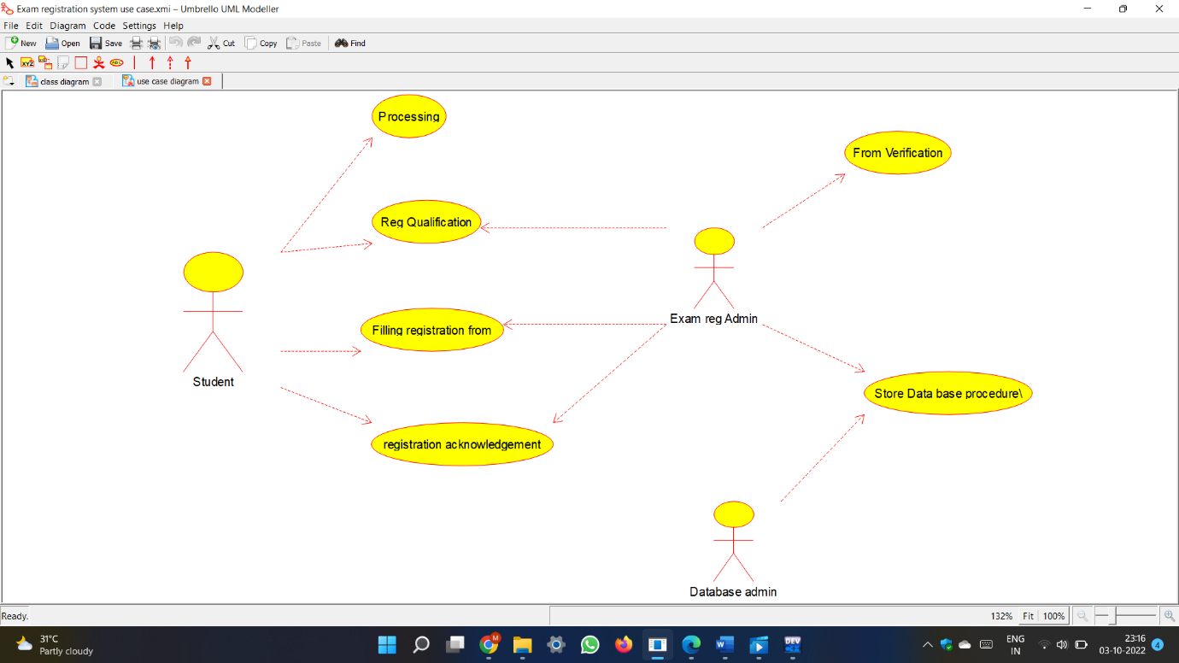

Class diagram :

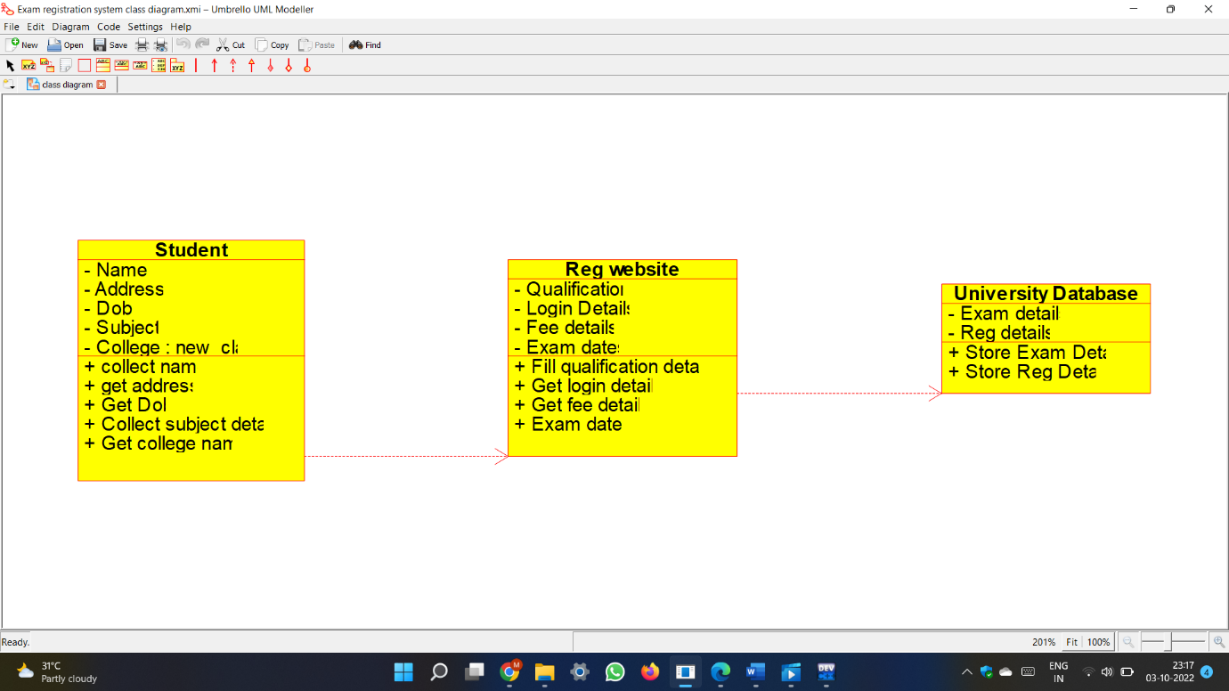

Code :

#ifndef STUDENT_H

#define STUDENT_H

#include <string>

/**

* class Student

*

*/

class Student

{

public:

// Constructors/Destructors

//

/**

* Empty Constructor

*/

Student ();

/**

* Empty Destructor

*/

virtual ~Student ();

// Static Public attributes

//

// Public attributes

//

// Public attribute accessor methods

//

// Public attribute accessor methods

//

/**

*/

void collect_name ()

{

}

/**

*/

void get_address ()

{

}

/**

*/

void Get_Dob ()

{

}

/**

*/

void Collect_subject_details ()

{

}

/**

*/

void Get_college_name ()

{

}

protected:

// Static Protected attributes

//

// Protected attributes

//

public:

// Protected attribute accessor methods

//

protected:

public:

// Protected attribute accessor methods

//

protected:

private:

// Static Private attributes

//

// Private attributes

//

void Name;

void Address;

void Dob;

void Subject;

new_class College;

public:

// Private attribute accessor methods

//

private:

public:

// Private attribute accessor methods

//

/**

* Set the value of Name

* @param new_var the new value of Name

*/

void setName (void new_var) {

Name = new_var;

}

/**

* Get the value of Name

* @return the value of Name

*/

void getName () {

return Name;

}

/**

* Set the value of Address

* @param new_var the new value of Address

*/

void setAddress (void new_var) {

Address = new_var;

}

/**

* Get the value of Address

* @return the value of Address

*/

void getAddress () {

return Address;

}

/**

* Set the value of Dob

* @param new_var the new value of Dob

*/

void setDob (void new_var) {

Dob = new_var;

}

/**

* Get the value of Dob

* @return the value of Dob

*/

void getDob () {

return Dob;

}

/**

* Set the value of Subject

* @param new_var the new value of Subject

*/

void setSubject (void new_var) {

Subject = new_var;

}

/**

* Get the value of Subject

* @return the value of Subject

*/

void getSubject () {

return Subject;

}

/**

* Set the value of College

* @param new_var the new value of College

*/

void setCollege (new_class new_var) {

College = new_var;

}

/**

* Get the value of College

* @return the value of College

*/

new_class getCollege () {

return College;

}

private:

void initAttributes () ;

};

#endif // STUDENT_H

#ifndef REG_WEBSITE_H

#define REG_WEBSITE_H

#include <string>

/**

* class Reg_website

*

*/

class Reg_website

{

public:

// Constructors/Destructors

//

/**

* Empty Constructor

*/

Reg_website ();

/**

* Empty Destructor

*/

virtual ~Reg_website ();

// Static Public attributes

//

// Public attributes

//

// Public attribute accessor methods

//

// Public attribute accessor methods

//

/**

*/

void Fill_qualification_details ()

{

}

/**

*/

void Get_login_details ()

{

}

/**

*/

void Get_fee_details ()

{

}

/**

*/

void Exam_dates ()

{

}

protected:

// Static Protected attributes

//

// Protected attributes

//

public:

// Protected attribute accessor methods

//

protected:

public:

// Protected attribute accessor methods

//

protected:

private:

// Static Private attributes

//

// Private attributes

//

void Qualification;

void Login_Details;

void Fee_details;

void Exam_dates;

public:

// Private attribute accessor methods

//

private:

public:

// Private attribute accessor methods

//

/**

* Set the value of Qualification

* @param new_var the new value of Qualification

*/

void setQualification (void new_var) {

Qualification = new_var;

}

/**

* Get the value of Qualification

* @return the value of Qualification

*/

void getQualification () {

return Qualification;

}

/**

* Set the value of Login_Details

* @param new_var the new value of Login_Details

*/

void setLogin_Details (void new_var) {

Login_Details = new_var;

}

/**

* Get the value of Login_Details

* @return the value of Login_Details

*/

void getLogin_Details () {

return Login_Details;

}

/**

* Set the value of Fee_details

* @param new_var the new value of Fee_details

*/

void setFee_details (void new_var) {

Fee_details = new_var;

}

/**

* Get the value of Fee_details

* @return the value of Fee_details

*/

void getFee_details () {

return Fee_details;

}

/**

* Set the value of Exam_dates

* @param new_var the new value of Exam_dates

*/

void setExam_dates (void new_var) {

Exam_dates = new_var;

}

/**

* Get the value of Exam_dates

* @return the value of Exam_dates

*/

void getExam_dates () {

return Exam_dates;

}

private:

void initAttributes () ;

};

#endif // REG_WEBSITE_H

#ifndef UNIVERSITY_DATABASE_H

#define UNIVERSITY_DATABASE_H

#include <string>

/**

* class University_Database

*

*/

class University_Database

{

public:

// Constructors/Destructors

//

/**

* Empty Constructor

*/

University_Database ();

/**

* Empty Destructor

*/

virtual ~University_Database ();

// Static Public attributes

//

// Public attributes

//

// Public attribute accessor methods

//

// Public attribute accessor methods

//

/**

*/

void Store_Exam_Details ()

{

}

/**

*/

void Store_Reg_Details ()

{

}

protected:

// Static Protected attributes

//

// Protected attributes

//

public:

// Protected attribute accessor methods

//

protected:

public:

// Protected attribute accessor methods

//

protected:

private:

// Static Private attributes

//

// Private attributes

//

void Exam_details;

void Reg_details;

public:

// Private attribute accessor methods

//

private:

public:

// Private attribute accessor methods

//

/**

* Set the value of Exam_details

* @param new_var the new value of Exam_details

*/

void setExam_details (void new_var) {

Exam_details = new_var;

}

/**

* Get the value of Exam_details

* @return the value of Exam_details

*/

void getExam_details () {

return Exam_details;

}

/**

* Set the value of Reg_details

* @param new_var the new value of Reg_details

*/

void setReg_details (void new_var) {

Reg_details = new_var;

}

/**

* Get the value of Reg_details

* @return the value of Reg_details

*/

void getReg_details () {

return Reg_details;

}

private:

void initAttributes () ;

};

#endif // UNIVERSITY_DATABASE

_H

Activity diagram :

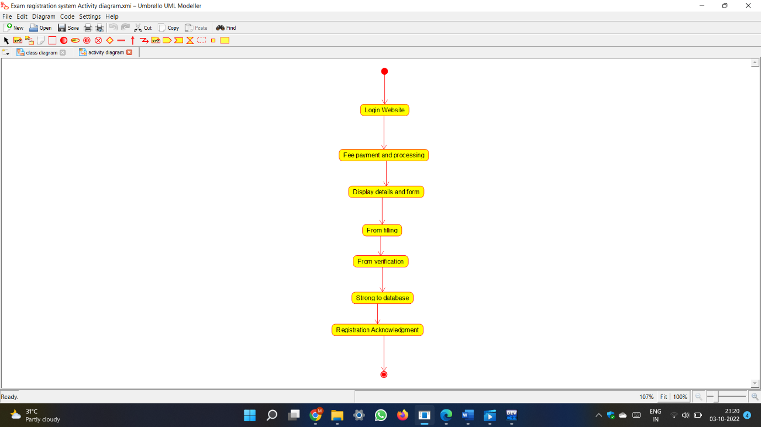

Sequence diagram :

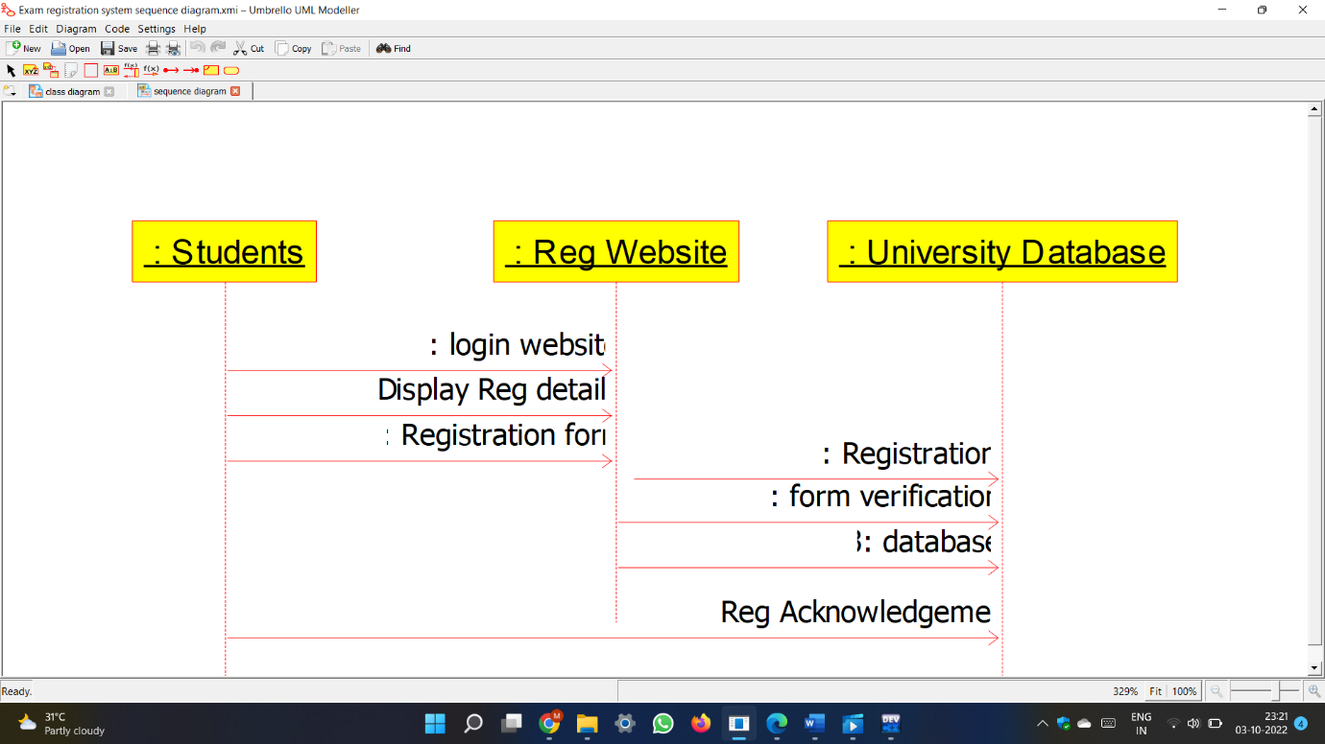

Component diagram :

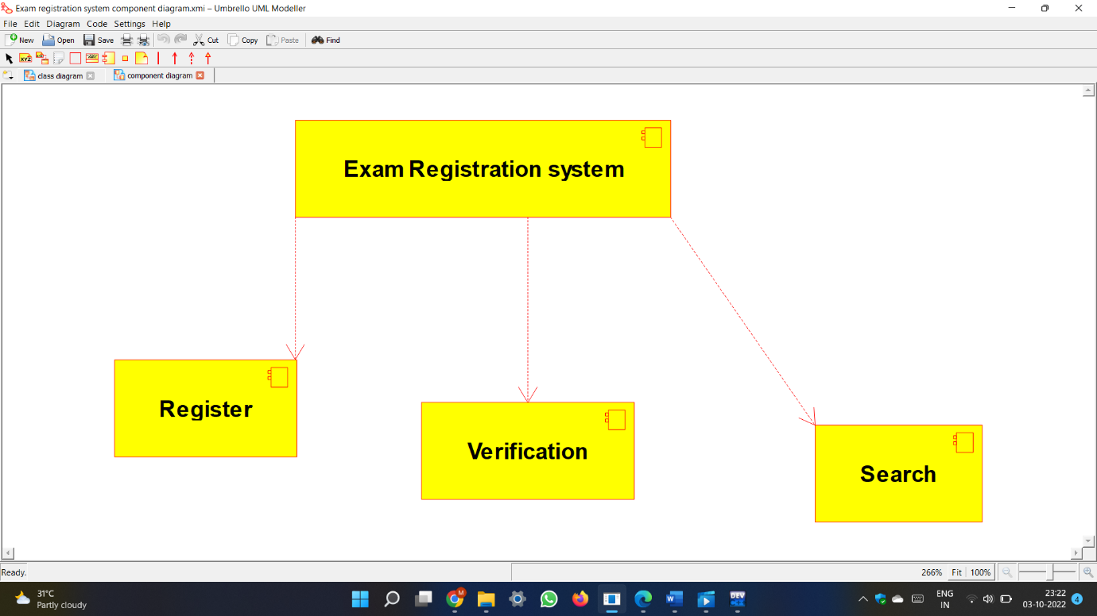

Deployment Diagram :

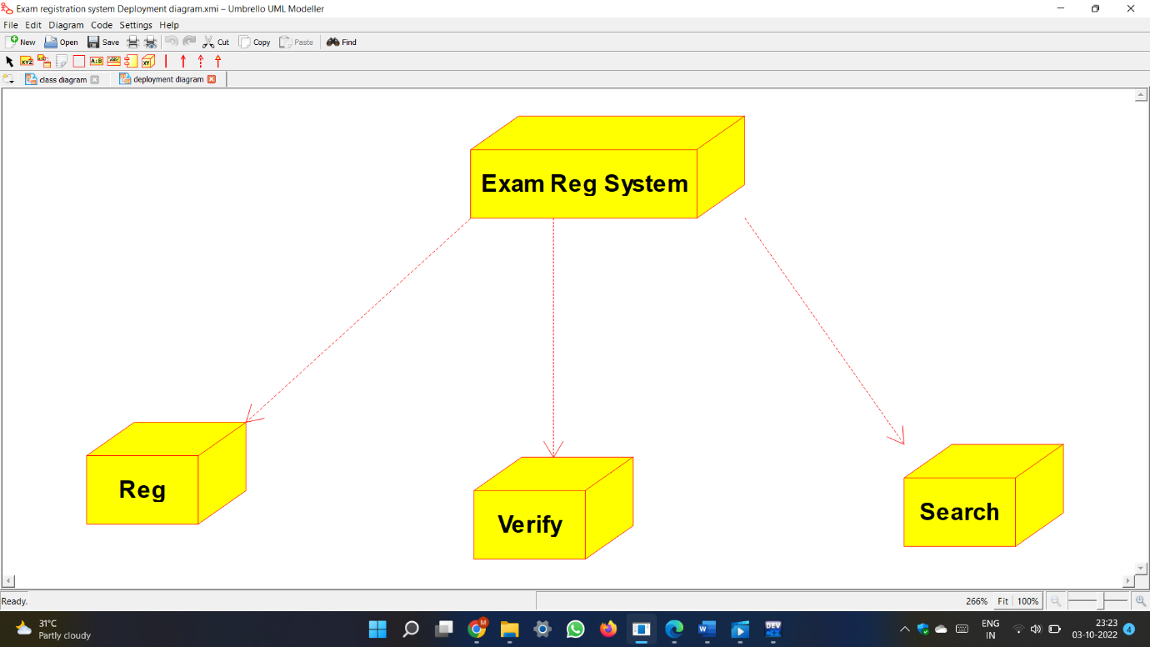

State chart diagram :

